Task 1 Index Page 12 marks
Instructions

- Create an index.html page which has one headboard and three columns as shown in the given file PageLayout.GIF. You need to write the HTML code by using a division for each area and using the CSS styles defined for each division in the given file style.css. (5 marks)

- Attach the given file style.css to index.html as an external CSS file. (2 marks)

- Inside the given file style.css, define a CSS class heading which will have an appropriate font face, font size and will be centred. Use this class and add a heading “Nike Shoes” to the middle columns of index.html. (4 marks)

- Please add a proper title to index.html. (1 mark)

Task 2 CSS Menu 12 marks
Instructions

In this task, you will create a menu for your website by using CSS. The menu is similar to the following:

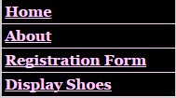

- Continue to work on index.html. You should add the HTML code related to the menu in the left column of the page. You should display the menu as an unordered list by using the given CSS code. Each menu item should be a link.
(5 marks)

- When Home is clicked, file index.html will be displayed. When About is clicked, file about.html will be displayed. When Registration Form is clicked, file registration.html will be displayed. When Display Shoes is clicked, file display.html will be displayed. (4 marks)

- Inside the file style.css, define appropriate text font, font size, colour and background colour for page body. Set margin and padding as 0px. (3 marks)

Task 3 Add Header Board 18 marks
Instructions

In this task, you will display the header board image.

- Continue to work on index.html. Include the given javascript file nike.js in the <head> section of index.html. (1 mark)

- Create a folder images. Copy given images nike -banner1.jpg, nike -banner2.jpg, nike -banner3.jpg, nike -banner4.jpg and nike -banner5.jpg into this folder.
(2 marks)

- Display image bird-banner1.jpg in the headboard division with width="900", height="300", name and ID as “board” (4 marks)

- Inside the <body> tags create a <div> with an id=”wrapper”. In the style.css, create #wrapper with a width of 900px, and margin of 0 on the top and auto on all side. This will align the whole contents of the body in the center. (4 marks)

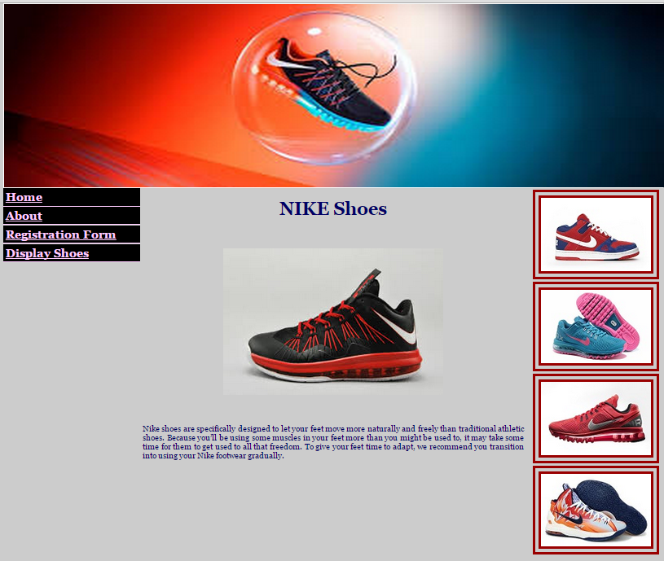

- When the page is loaded, function fading_rotating should be called, which is defined within file nike.js. You should see the five images rotating here.
(1 marks)

- Inside index.html, include the given file SpryEffects.js as an external file. Inside file nike.js, call function Spry.Effect.DoFade properly from function fading_rotating such that the images will be fading into almost becoming invisible after each rotation. (5 marks)

- Save index.html as registration.html, display.html and about.html respectively.
(1 marks)

Task 4 Work on Index Page 22 marks
Instructions

In this task, you will work on index.html page, the outcome of which is similar to the following:

- Continue to work on the index.html page. Copy the given image files small1.jpg, small2.jpg, small3.jpg, small4.jpg, large1.jpg, large2.jpg, large3.jpg, large4.jpg and front-nike.gif into images folder. Insert the image front-nike.gif into the middle column after the CSS class heading by using a division. Define a CSS class front inside file bird.css and apply it to make front-nike.gif center aligned and leave 30px margin at both the top and the bottom.
(6 marks)

- Add the text in the Home Page section of file Information.doc to the bottom of the middle column of the index page. Put the text in a division and apply CSS class description defined in file bird.css to the division. (4 marks)

- Modify JavaScript function smallImages defined in the file nike.js so that it still works correctly for all the eight images (small1.jpg – small4.jpg, large1.jpg – large4.jpg) provided from the folder images. (4 marks)

- Call function smallImages from the right column of index.html to display 4 small image links vertically. (4 marks)

- Inside file index.html, include the given file jquery.js as an external file. Make sure that jquery.js is included before file nike.js. When mouse is over an image link, the same image with a large size will be displayed. Modify the jQuery function inside the file nike.js so that the position for a large image will go up 50px from the current position. (4 marks)

Task 5 Shoe Gallery Page 12 marks
Instructions

In this task, you will work on display.html, the outcome of which is similar to the following:
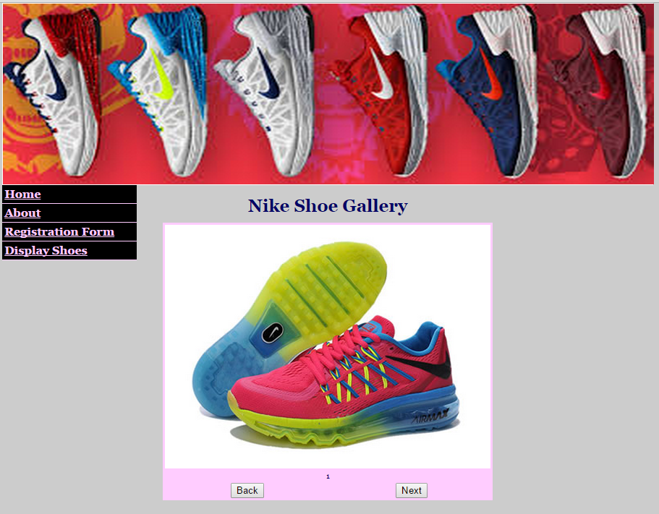

- Open display.html page. Use the predefined CSS class heading and add the heading “Nike Shoe Gallery” to display.html page. Add a proper title to display.html. (2 marks)

- Copy the given image files slide1.jpg, slide2.jpg, slide3.jpg, slide4.jpg, slide5.jpg and slide6.jpg into images folder. (2 marks)

- Copy all the code from Table.doc to the middle column after the heading.
(2 marks)

- Define function goforward() within file bird.js, and call it from display.html such that when Next button is clicked the next image should be displayed in the order: slide1 to slide2 ... slide6. (6 marks)

Task 6 About Page 8 marks
Instructions

In this task, you will work on about.html page, the outcome of which is similar to the following:

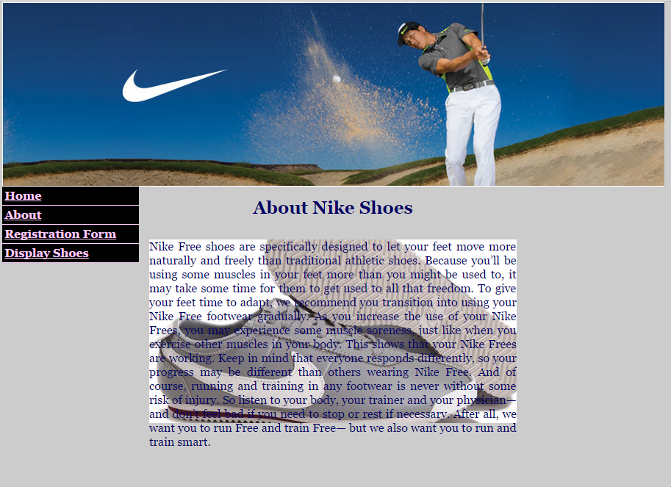

- Open about.html page. Use the predefined CSS class heading and add the heading “About Nike Shoes” to about.html. Add a proper title to about.html.
(2 marks)

- Add the text in the About section of file Information.doc into the middle column after the CSS class heading. Make use of the predefined division ID transbox from the given file style.css. Copy given image background-nike.gif to the images folder. Add the correct JavaScript event handlers such that when the mouse pointer is over the box, the box will be fully visible, when the mouse pointer is out of the box, the box is back to being partially visible. It should work for IE and other browsers. (6 marks)

Task 7 Registration Form 16 marks
Instructions

In this task, you will add a registration form, the outcome of which is similar to the following:

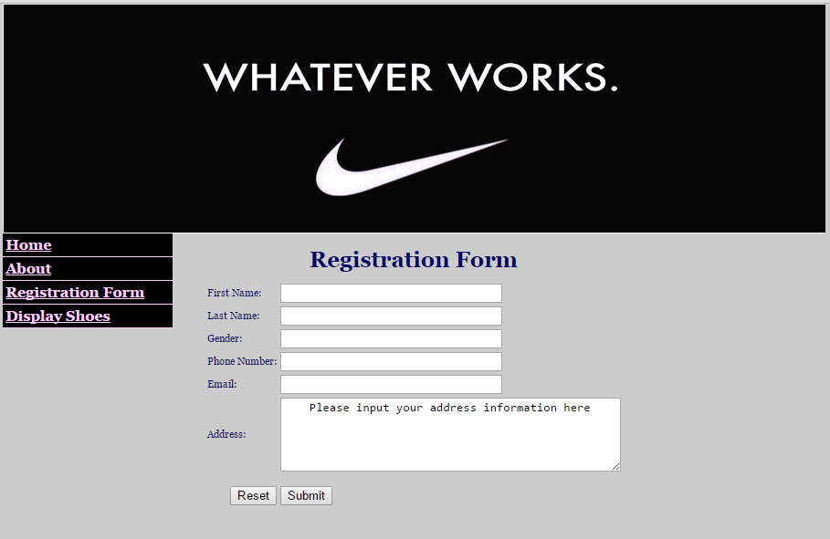

- Open registration.html page. Use the predefined CSS class heading and add the heading “Registration Form” to registration.html page. Add a proper title to registration.html. (2 marks)

- Add the above form to the middle column of this page after the CSS class heading. (4 marks)

- There is a function validate_form defined in the given file bird.js. This takes the form as a parameter and checks the Email Address field of the form by calling function validate_email(field,alerttxt). If the email address is not valid, it will display the message “The input email address is not valid!” and then set the cursor focus to the email field. Add a function validate_email(field,alerttxt) to file bird.js, which checks if the input email address contains a symbol “@” which cannot be the first letter and a “.”. The first “.” must be at least three characters away from the “@”, if the email address is invalid, the given “alerttxt” will be displayed. (8 marks)

- Call the function validate_form when the form is submitted. (2 marks)

